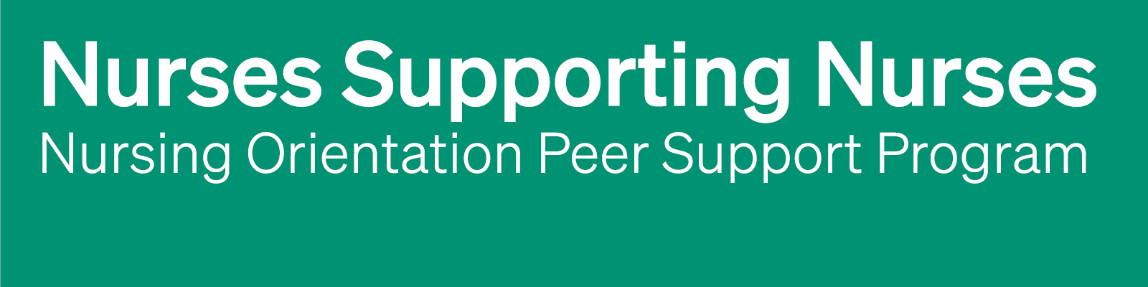
NOPSP Email Templates
Email templates that can be used to support communication with participants of the Nursing Orientation Peer Support Program (NOPSP).
Instructions for implementing long-term care home
The following email templates are provided to help you communicate with the Orientation Partner and new nurse at key points throughout the Nurses Supporting Nurses: Orientation Peer Support Program (NOPSP).
Ideally, these emails are sent by the NOPSP Coordinator to Orientation Partners and newly hired nurses. The templates include emails to initiate the partnership, check in with the Orientation Partner, check in with the new nurse, and close the partnership. They are intended as a starting point and can be adapted to reflect my own communication style, the needs of the participants, and the context of the partnership.
You do not need to use the templates word-for-word. The goal is to provide a simple structure that helps me maintain communication, encourage meaningful connection, and support the partnership throughout the six-week program. Any text in [Green] highlights areas that may need to be personalized, such as names.
For more information about using the NOPSP Email Templates while implementing a NOPSP, please see Perley Health’s Nurses Supporting Nurses: Building an Orientation Peer Support Program. PerleyHealth.ca/orientation-peer-support-program

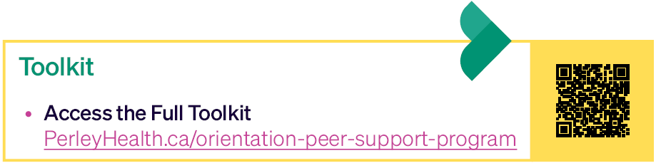

NOPSP Email Templates
- Initial Pairing
Email directions:
- Email directly to the newly hired nurses and CC the assigned Orientation Partner.
- Send email with high importance.
Subject line: Important Onboarding Information: Nursing Orientation Peer Support Program
Body of email:
Hello [Name of New Hire],
Welcome to [Name of Home] and I hope your first few days have gone well!
I am reaching out to connect you with [Name of Assigned Orientation Partner], they will be your Orientation Partner for the next 6 weeks. This is the next phase of your onboarding. During your transition to your new role, if needed, please contact [Name of Assigned Orientation Partner], if you have any process or resource related questions. [Name of Assigned Orientation Partner], will also check in with you weekly to see how you are doing over the next 6 weeks. Please feel free to choose your method of communication, text, phone or in person. It should be at your convenience. The expectation is for you to connect with your Orientation Partner at least once a week.
Also, please feel free to reach out to me if you have any questions or concerns.
Thanks so much for joining the team,
[Name of NOPSP Coordinator]

- Two-Week Check in with New Hire

Email directions:
- Send with high importance.

Subject line: Two-Week Check in - Nursing Orientation Peer Support Program

Body of email:

Hello [Name of New Hire],
I hope this email finds you well and that you have been feeling more settled in your new role.
As you are currently participating in the [Name of Home]’s Nursing Orientation Peer Support Program, I wanted to take a moment and check in on how your peer support journey is progressing?
I hope you have had some time to connect with your paired Orientation Partner and are transitioning smoothly into your new role. Please note that connecting with your Orientation Partner once a week, for six weeks, is a mandatory requirement of onboarding.
If you haven’t had a chance to connect, or you have any concerns, please do not hesitate to reach out to me.
Thank you for your commitment to your onboarding and our peer support program.
Warm regards,
[Name of NOPSP Coordinator]

- Two-Week Check in with Orientation Partner
Email directions:
- Send with high importance.

Subject line: Two-Week Check in - Nursing Orientation Peer Support Program

Body of email:

Hello [Name of Orientation Partner],
I hope this email finds you well.
Thank you for being an Orientation Partner for [Name of New Hire] who is participating in the [Name of Home]’s Nursing Orientation Peer Support Program, I wanted to take a moment and check in on how the partnership is progressing? I hope you have had some time to connect with your paired new hire. Please note that your new hire connecting with you once a week, for six weeks, is a mandatory requirement of their onboarding.
If you haven’t had a chance to connect, or you have any concerns, please do not hesitate to reach out to me.
Thank you for your commitment to creating a welcoming environment and supporting new team members,
Warm regards,
[Your Name]

- End of Partnership
Email directions:
- Email both the new hire and the Orientation Partner, together.
- Send with high importance.

Subject line: Two-Week Check in - Nursing Orientation Peer Support Program

Body of email:

Hello [Name of New Hire] and [Name of Orientation Partner]
I hope this email finds you well!
I wanted to reach out to let you know that you have officially reached the end of [Name of Home]’s Nursing Orientation Peer Support Program.
Thank you both for taking the time to participate in the program and for the support and connection you brought to the partnership.
[Name of New Hire], wishing you all the best as you continue settling into your role. We’re so happy to have you as part of the team!
[Name of Orientation Partner], thank you for your time, support, and commitment to welcoming and supporting a new nurse.
[As a final step, I will be sending a brief evaluation to gather your feedback and learn how we can continue to strengthen the program for future participants. This is anonymous and optional.]
Thank you both for taking the time to participate in this program.
Warm regards,
[Your Name]

