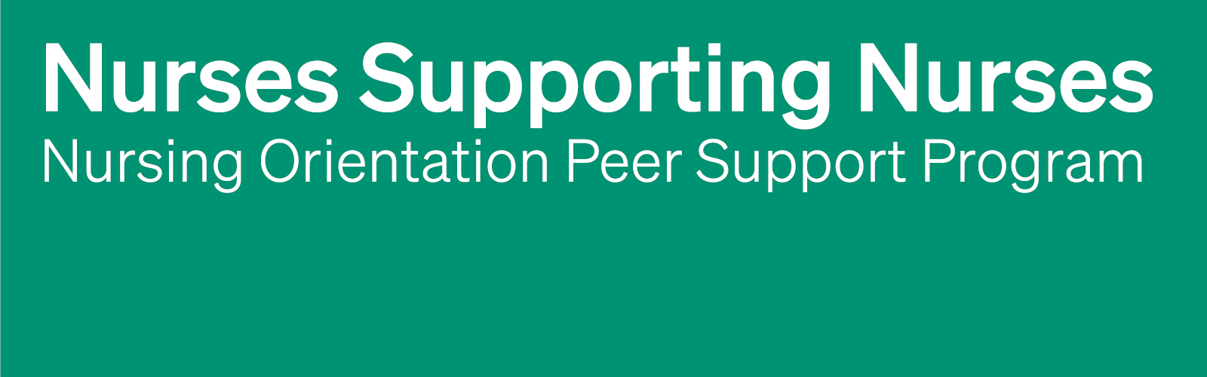
Program Overview: Outlining Roles, Expectations, and Scope
A one-paged handout for long-term care homes to give to participants of their Nursing Orientation Peer Support Program (NOPSP).
Instructions for implementing long-term care home
The handout below is intended to inform NOPSP participants, both Orientation Partners and new hires, about the roles, expectations, boundaries, and scope of the program.
The handout below is a template and can be edited to align with your home’s needs. Any text that is [Green] may need to be personalized, such as names.
For more information about using the NOPSP Program Overview handout as part of the NOPSP implementation in long-term care, please see Perley Health’s Nurses Supporting Nurses: Building an Orientation Peer Support Program. PerleyHealth.ca/orientation-peer-support-program

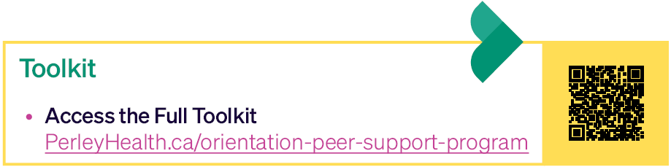

NOPSP Pre-Implementation Questionnaire
Program Overview: Outlining Roles, Expectations, and Scope

Program Purpose
The Nursing Orientation Peer Support Program (NOPSP) is designed to help new nurses feel welcomed, supported, and connected as they begin their journey at [Name of Home]. Over six weeks, newly hired RNs and RPNs are paired with experienced staff Orientation Partners who provide encouragement, share organizational knowledge, and help new team members navigate their transition into their role and the [Name of Home]. community.

NOPSP Roles, Responsibilities, and Expectations

New Hire
New hires are expected to:
- Check-in once a week with your Orientation Partner in-person, by phone, or by email
- Engage actively in peer support conversations and activities.
- Ask questions, seek clarification, and use the Orientation Partner as a resource during their transition.
- Be open to feedback, reflection, and learning from both successes and challenges.
- Communicate learning needs, challenges, or barriers that may impact their transition.
- Demonstrate professionalism, respect, and person-centred care in all interactions.
- Identify concerns early and connect with the NOPSP Coordinator when additional support is required.

Orientation Partner
Orientation Partners are expected to:
- Check-in once a week with your new hire in-person, by phone, or by email
- Provide encouragement, guidance, and organizational support within the scope of the role (see below)
- Create a safe and welcoming environment where questions and conversations are encouraged.
- Share knowledge about the [Name of Home’s] environment, resources, and workplace culture.
- Identify concerns early and connect with the NOPSP Coordinator when additional support is required.

NOPSP Coordinator
The NOPSP Coordinator supports successful partnerships by:
- Providing guidance and clarification regarding program roles, expectations, and processes.
- Supporting participants with challenges related to the peer support partnership.
- Connecting participants with additional organizational resources, supports, and subject matter experts.
- Helping ensure consistent implementation of the NOPSP across the home.

Scope of the Orientation Partner

The table below demonstrates what support is appropriate for an Orientation Partner to provide for a new hire.
Within the Scope of an  Orientation Partner | Outside the Scope of an  Orientation Partner
- Answer questions  - Guide new hire to policies, procedures, and other resources  - Share personal experiences of onboarding  - Discuss concerns, offer advice, and support new hire in problem solving  - Promote confidence and encourage new hire  - Provide constructive feedback | - Demonstrate clinical skills  - Offer shadow shifts  - Complete tasks for the new hire  - Develop and monitor a performance improvement plan  - Offer peer support outside of scheduled work hours

If the new hire demonstrates a higher need for support outside the scope of an Orientation Partner, the new hire should connect with the NOPSP Coordinator for guidance.

The NOPSP Partnership
The NOPSP is built on connection, encouragement, and shared knowledge. Together, new hires and Orientation Partners help create a supportive transition experience where new team members feel welcomed, informed, and connected to the [Name of Home]’s community.

