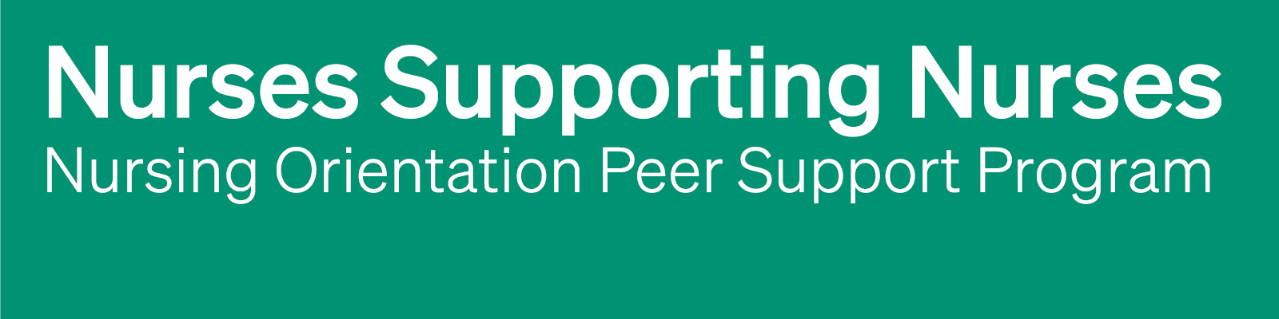
NOPSP Pre-Implementation Questionnaire
A questionnaire template for long-term care homes considering implementing a Nursing Orientation Peer Support Program (NOPSP).
Instructions for implementing long-term care home
The questionnaire below is intended to gather insights from nurses about their experience transitioning into their new role within your home when they were first hired. Responses will help you better understand the challenges, supports, and resources that influenced their onboarding experiences and identify opportunities to enhance support for newly hired nurses within your home. Findings from this survey will be useful to inform your team decisions regarding the adoption and implementation of a NOPSP.
It is recommended that you approach nurses who have worked at your organization one year or less. The questionnaire below is a template and can be edited to align with your home’s needs. Any text in [Green] highlights areas that may need to be personalized, such as names.
For more information about using the NOPSP Pre-Implementation Questionnaire while implementing a NOPSP, please see Perley Health’s Nurses Supporting Nurses: Building an Orientation Peer Support Program. PerleyHealth.ca/orientation-peer-support-program

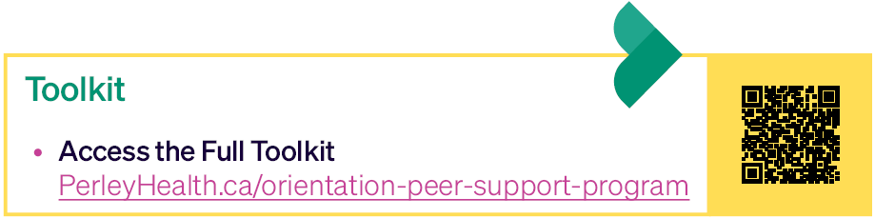

NOPSP Pre-Implementation Questionnaire
[Name of Home] is considering adopting and implementing a Nurse Orientation Peer Support Program (NOPSP) to better support newly hired nurses as they transition into our team.

We invite you to reflect on your experience when you first joined our organization and answer the following questions based on that experience.

Your feedback will help inform our decision about whether and how to implement a NOPSP. Thank you for taking the time to share your insights and support this initiative.

- Tell me about your experience as a new hire at [Name of Home]
  - Considerations: What went well? What challenges did you experience? What supports were helpful during your transition

- Do you think having a dedicated mentor or peer support person would have been helpful during your transition to working at [Name of Home]? Why or why not?

- If [Name of Home] were to develop a nursing mentorship or peer support program, what types of resources or activities do you think would be helpful?
  - Examples: workshops, online resources, e-learning, toolkits, check-ins, networking opportunities.

